Contents to consider including in a Pet Emergency Evacuation Kit |  | TICK
A suitable secure carrier for your pet; | 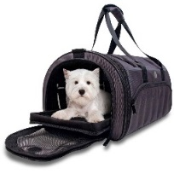
A suitable harness/lead for your pet;

A collar with a name tag and telephone number;

If your pet is on medications – make a list of them and have a supply available;

Keep copies of pet vaccination certificates, pet insurance information and other important pet documents in your Emergency Grab Bag;

Food, water, bowls, spoon plus a can opener (if necessary);

Pet litter, ‘pooper scooper’ and plastic bags;

Hand sanitizer/household bleach;

Paper towels;

Toys (familiar items may help reduce stress to your pet(s)).

