Suggested contents to include in an Emergency Grab Bag –  you may want to amend this checklist to include your own items |  |  | TICK
any regularly prescribed medication; | 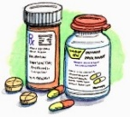
toiletries and sanitary supplies;

first aid kit; | 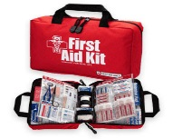
bottled water, snack bars and tinned foods;

glasses or contact lenses; | 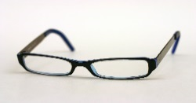
nappies and other essentials for babies;

mobile phone and charger; | 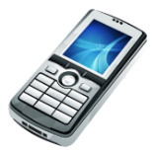 | 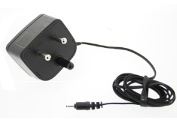
cash and credit/debit cards; |  | 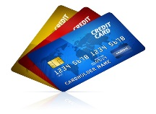
pocket torch and spare batteries; |  | 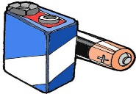
battery-powered or wind-up rechargeable radio; | 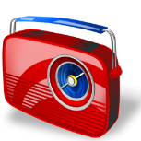
important documents (eg. passports, driving licences, insurance certificates); | 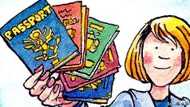
useful telephone numbers (eg. family, friends, insurance company, utilities, doctors etc);
essential keys (house, car etc); | 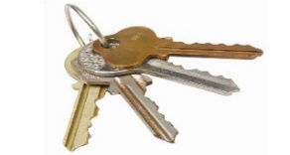
spare clothes and blankets.

